Mail Call’

Mount Olympus Detachment #897 Newsletter
June-September ‘15

2015 Detachment Officers

Commandant: Sid Gerling sidjean6@gmail.com
Sr Vice Commandant: Guy Iredale guy092248@hotmail.com
Jr.Vice Commandant: Mark Schildknecht marana@tfon.com
Chaplain: Marty Gutowski gutowski@cox.net
Adjutant/Paymaster: Kathy Nicholls kmt@wavecable.com
Sgt. At Arms: Mark Schildknecht

Toys for Tots Coordinator: Steve Deutermann deutermann@juno.com

Det. Newsletter Editor Diana Schildknecht marana@tfon.com

Next meeting: Tuesday, October 27, 2015; 1800 (6PM); Veterans Center-261 S Francis St, Port Angeles, Wa.

Now Hear This:

Our Detachment has a new website, thanks to Adjutant/Paymaster Kathy Nicholls…http://mtolympus897.weebly.com/ . Kathy has put a lot of time & effort into creating this clean looking website, which still has parts ‘under construction’. However, you will find pictures of Detachment members, newsletters and information concerning the upcoming Marine Corps Birthday Ball…be sure to ‘check it out’.

Message From The Detachment Commandant:

“I hope everyone can, and will, attend the Marine Corps Birthday celebration and our first meeting, at the vet center, since our summer recess. We will also have a detachment Christmas dinner in December. Date and time TBA.”

Honor Guard Stastics for This Quarter:

Members: 11
Dan Abbott Don Alward Don Clayton Bob Camp Steve Deutermann Frank Donnelly Sid Gerling
Marty Gutowski Guy Iredale Eric Miner Mark Schildknecht
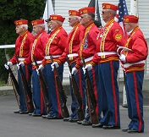

Events: (June-September)

Funerals: 9
Last Friday of each month Veterans Park Bell Ringing: 4
Ceremonies:2
Total Honor Guard 2015 activities participation for the year to date: 33

Ceremonies:
10 June Marvin Shields 50the Rememberance Ceremony
11 September Patriot Day Ceremony
20 September MIA/POW Highway Rededication

Funerals/Memorials have been in various locations besides local cemeteries: Veterans Center, John Wayne Marina, Sit-n-Bull (private club), & church parking lots.

June through September this year was a very busy time for many of our members:

Activities Participated in by Members Representing Mt. Olympus Detachment:

10 June Marvin Shields 50th Rememberance Ceremony

June 10th marked the 50th Rememberance of the death of Marvin Shields, the only Seabee to receive the medal of honor which was awarded posthumously. Our Detachment felt ‘honored’ to participate in providing the Rifle Salute. Almost all Honor Guard members were able to participate: Don Alward, Frank Donnelly, Steve Deutermann, Sid Gerling, Marty Gutowski, Guy Iredale, and Eric Miner.

4 July Forks July 4th Parade

Don Alward, Don Clayton, Steve Deutermann, Sid Gerling and Guy Iredale represented our Detachment driving the M-37 in the parade. The M-37 took 3rd place for ‘Military Entry’ & won a White Ribbon.

12 July Annual Detachment Picnic

Dan & Wendy Abbott graciously opened their home to Detachment members & guests. Dan had recently underwent major surgery but that didn’t stop him from being the perfect host. Wendy did most of the preparation because Dan was on light duty. Plenty of sunshine and a fun time along with great food and attendance created an atmosphere of a good time had by all. Thanks Dan & Wendy.

27 July Port Townsend Standown
Steve Deutermann, Sid Gerling, Guy Iredale, and Maggie Roth assisted at the Stand Down.

1 August Joyce Daze Parade

Our Detachment received a 1st place ribbon for Military Entry with the M- 37. Don Alward, Don Clayton, Steve Deurtermann and Maggie Roth participated on behalf of our Detachment.

8 August Home Depot Veterans Appreciation Day

Bob Camp. Steve Deutermann, Sid Gerling & Guy Iredale set up and manned Dan Abbott’s red Marine Corps canopy. They displayed our usual MCL information and a large board containing pictures of past MCL Detachment #897 events. One person requested/received an application.

9 August Sprint Boat Races

Several members helped provide security at the entrances to the Sprint Boat Races held in Port Angeles. Donations to our Detachment: $515; also one membership application was requested & given.

9-15 August Nationl MCL Convention in Scottsdale, Arizona

Mark & Diana Schildknecht drove to Scottsdale to attend the annual MCL National Convention that is held in a different location each year. Their main purpose was for Mark to move up to a pedigree in the MCL Devil Dogs organization. Other than 114º temps (101º) one night, Mark having to wear a dress & jewelry for 3 days as part of his initiation & driving the last 6 days home in a smoky haze due to wildfires in the west, they had a fun time. They made new friends from all over the US. On their return trip they stopped at the beautiful Anthem Veterans Memorial in Anthem, Arizona.
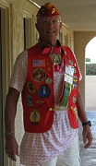 Mark in his pink dress, red dog collar and jewelry. 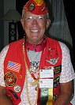 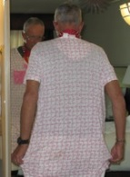

15 August Fort Discovery

Our Detachment was unable to attend due to prior commitments.

3 September Sarge’s Place

Guy Iredale performed the landscaping and drain field preparation for Sarge’s Place in Forks.

19 September POW/MIA Highway Redication

Detachment members in attendance were Don Alward, Bob Camp, Don Clayton, Sid Gerling, Guy Iredale, and Maggie Roth. The Honor Guard members performed a rifle salute.

MCL Ball:
When: November 14, 2015; 5:30pm
Location: Sequim Elks Lodge; 143 Port Williams Rd., Sequim WA
Cost: $35 per person
Social Hour: 5:30 pm no-host; with dinner and ceremony to begin at 6:30 pm.

Member Profile of the Quarter

Donald Alward

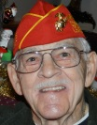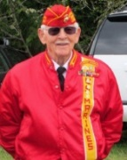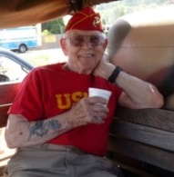

USN 1942-1946
USN Reserve 1946-1954

WWll Veteran

Rank: Signalman Third Class

‘Job’: Signalman on the Destroyer USS Bradford 545.

‘Campaigns’: 13 major battles, which included Gilbert-Marshall Island, Hollandia New Guinea, Marianas, Iwo Jima, Okinawa & the first amphibious landing on Kogoshima, Japan. The Bradford trained with two companies of Marines for the Iwo Jima battle. Don saw the “first flag raising at Mount Suribachi (which was not the one in the famous photo)”.

Don was “given a special OK’ to play his bagpipes at the USS Arizona Memorial on October 17th 2005, after a ‘few strings were pulled’ with the Navy and the National Park Service. Usually the Park Service only allows bugles to be played. This was a dream come true for Don, who wanted to Honor the sailors lost more than 60 years ago (at that time) of the USS Arizona. At the same time he also played five other military tunes (before Amazing Grace) for a re-enlistment ceremony of 70 who had just returned from Afghanistan and Iraq.

Though Don is a Navy Veteran, he was accepted for membership in the Mt. Olympus Detachment #897 of the Marine Corps League in 1995. Don was/is a very important part of the foundation of the Detachment, due to his loyalty & commitment throughout all these years. He bagan as The Piper, and in later years became a member of the Honor Guard as a rifleman, & currently is the Bugler. Don received the designation of ‘Marine of the Year’ in 1997 as special recognition of his devotion, & received the ‘Honor Guard Bronze Numbered Statue’ for his exemplary dedication to the Corps. He, like other members of our Detachement, has received several medals & ribbons from the Marine Corps League.

More Detachment History

A Charter was granted to Detachment #897 on 4 October, 1994, with 25 ‘Charter’ members signing on the back. Of those 25 members, eight still belong today: Ray Chapman, Don Clayton, Otto Reiber, Tom McKewon Sr., Bob Mingram, Mark Schildknecht, Bill Terrill & Robert (‘R.P’) Wilson. Some have moved from the area; others have dropped their Detachment membership or have passed on (Jim Caldwell, Harry Findley, Ron Gates, Terry Roth, Dee Yager & possibly others of which we do not know).
By November 11th of that year, (five weeks later), 12 more members had been added, bringing a total membership by the end of the year to 37. A year later (1995) total membership had increased to 46, which included Don Alward, our featured member in this quarterly newsletter.
To be continued….

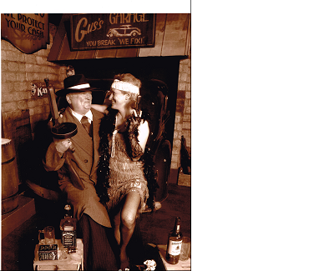Guess who?

If any member would like to share information concerning their participation in Detachment activities that I may have missed or do not know of, please email me at marana@tfon.com.

Due to constraints of space in this edition, I was not able to include information about a carving our Detachment received from a Detachment member, & also information on 2 Marine Corps related reunions another Detachment member attended. Watch for these to appear in the next edition of ‘Mail Call’.

If you do not wish to receive this email in your ‘inbox’ but instead prefer to read it on our new Detachment website (http://mtolympus897.weebly.com/), contact me & I will remove your email address from the mailing list.

Semper Fi
Submitted by newsletter editor, Diana Schildknecht

