Mount Olympus Detachment #897 Newsletter
October-December 2016

2015-2016 Detachment Officers

Commandant: Mark Schildknecht marana@tfon.com
Sr.Vice Commandant: Guy Iredale guy092248@hotmail.com
Jr.Vice Commandant: Sid Gerling sidjean6@gmail.com
Judge Advocate: Dan Abbott dwagabbott@msn.com
Chaplain: Sid Gerling sidjean6@gmail.com
Adjutant/Paymaster: Kathy Nicholls kmt@wavecable.com
Sgt. at Arms: Steve Deutermann deutermann@juno.com

Toys for Tots Coordinator: Steve Deutermann deutermann@juno.com
Det. Newsletter Editor Diana Schildknecht marana@tfon.com

Next meeting: Tuesday, January 24th, 2017; 1800 (6PM); Veterans Center-261 S Francis St, Port Angeles, WA.

Honor Guard Statistics for This Quarter:
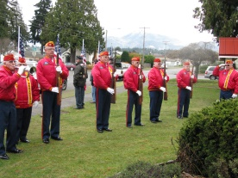 (Memorial at Veterans’ Center Dec. 18, 2016)
Members: 10

Dan Abbott, Don Alward, Don Clayton, Steve Deutermann, Frank Donnelly, Sid Gerling,
Guy Iredale, Eric Miner, Bob Nicholls, Mark Schildknecht.

Events: (October-December)

Funerals/Memorials: 6
Last Friday of each month Veterans Park Bell Ringing: 3

Ceremonies: 2 (Honor Guard divided into two groups for Veteran’s Day Ceremonies):
USCG Base Port Angeles
Gardiner Cemetery

Honor Guard’s events year end total: Funerals/Memorials-30; Ceremonies-9; Bell Ringings-12

New Member: (joined at December 11th Christmas Luncheon meeting)
Edmond Hart… WELCOME!
Member Profile of the Quarter

Frank Donnelly

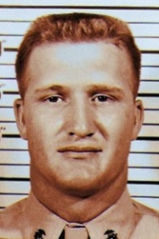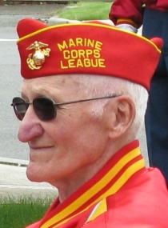
Boot Camp 1955 Detachment Honor Guard 2016

Frank’s ‘Stats’:

Rank: Corporal

Time In: January 4, 1955-December 20, 1957
MOS: 2533 Radio-Telegraph Operator (Morse Code) 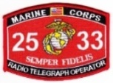

Duty Stations:
San Diego (Basic Training/Boot Camp)
Camp Pendleton (ITR)
San Diego (Communication-Radio Operator Training)
Middle Camp-Fuji Japan (located in the foothills of Mount Fuji. (“Good Duty”)
El Toro (Discharged from El Toro).
Military Medals and Awards Earned:
National Defense Expert shooting badge
Good Conduct

Joined Detachment #897: December 1998

Detachment Positions Held: Honor Guard Member

Alice (Frank’s wife): “Frank is really a low-key guy — he’s more than willing to work on projects but prefers to stay in the background. He also was in the National Guard for a little more than two years before joining the Corps”.
Frank was in the National Guard 10/30/52 — 1/3/55, then made an easy transition into the Marine Corps. On January 3, 1955 he was in the National Guard and the next day, January 4, 1955, he was in the Marines. The Marine Corps did all the paper work for the transition…all Frank had to do was show up at Boot Camp.

Activities Participated in by Mt. Olympus Detachment Members:

Department of Washington Marine Corp League Fall Staff meeting October 1, 2016:

Mark and Diana Schildknecht attended the annual Fall Staff meeting in Yakima. There is always new information passed on concerning the National as well as State Maine Corps League. Each Detachment presents a report of what they have been doing in the past 6 months.

Whidbey Island Marines Unit’s 12th Reunion October 1st-October 2nd:

Detachment members Kathy Nicholls, Don Clayton and Eric Miner belong to the ‘Whidbey Island Marines’ Unit’ and attended the Unit’s 12th Reunion at Camp Kirby on Sammamish Island. Attendance at this annual reunion is usually 30 to 40 members and guests.

Port Angeles Standown October 6, 2016:

The Port Angeles Stand Down was held at the Clallam County Fairgrounds. Detachment members Eric Miner, Guy Iredale, Mark Schildknecht, Sid Gerling and Steve Deutermann helped out with various duties, along with many other local Veterans’ organizations . Many services were provided free of charge to Veterans, as well as clothing and other supplies.

89th Birthday Celebration of Detachment Member:

Don Alward turned 89 years young on October 23rd. Several Detachment members surprised him (with wife Esther’s help). Esther later stated that “it was his first party”.
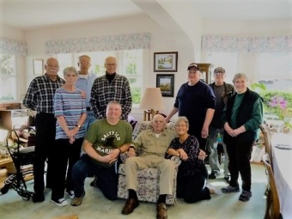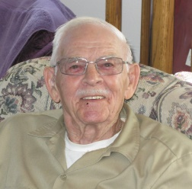

October 25th Luncheon Meeting at Smuggler’s Landing:

A luncheon ‘social’ replaced the monthly meeting for October. Twenty-three members and associate members attended. Michael Smith, a retired ‘Gunny’ was installed as the Detachment’s newest member.

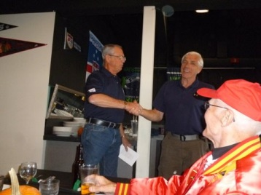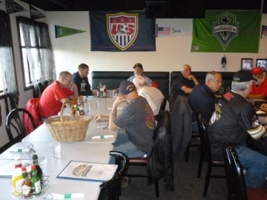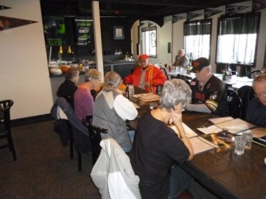

Detachment Members have Lunch at St Luke’s Episcopal Church in Sequim November 16th

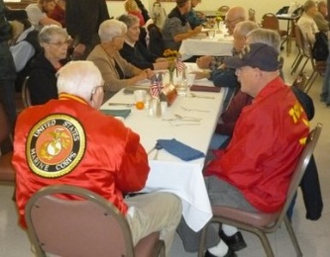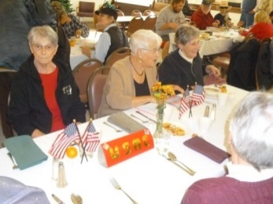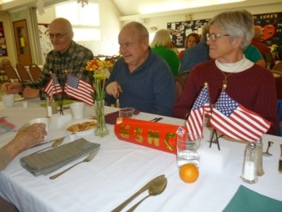

Veterans Day Ceremonies November 11th:

The Honor Guard once again divided their unit into 2 groups so that they may present the rifle salute at both the U.S. Coast Guard Base Port Angeles Sector, and also at the Gardiner Cemetery for local Medal of Honor Recipient Marvin Shields, USN.

Marine Corps 241st Birthday Ball November 12th:

Ninety Marines and guests attended the 241st Marine Corps Birthday celebration held at the Sequim Elks Lodge. A delicious dinner was followed by Port Angeles High School JROTC’s posting of the Colors. Commander Mark Hiigel of USCG Air Station/Sector Field Office Port Angeles was the guest speaker, with wife JoAnn and daughters Tana, Ellie and Kendra in attendance.
The oldest Marine present was Detachment member Tom McKeown at age 94 and the youngest Marine was Peyton Gagnon. The cake was ceremoniously presented by the JROTC after Detachment member Eric Miner read General John A. Lejeune’s Birthday Message.
Guy Iredale was selected as the Detachment 2016 Marine of the Year.
Brian Ledbetter, nationally recognized ‘Sensational Concert Mind Reader/Illusionist provided great entertainment.
Many wonderful items were auctioned off and a ‘big thanks’ goes out to Sid and Jean Gerling for gathering and assembling the items. Another ‘big thanks’ goes out to Kathy & Bob Nicholls who provided the programs, decorations and ceremonial music.

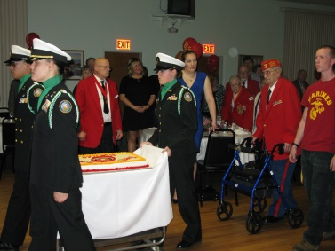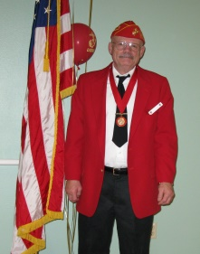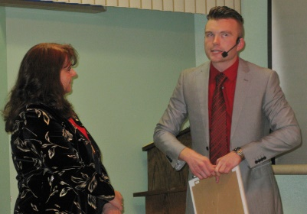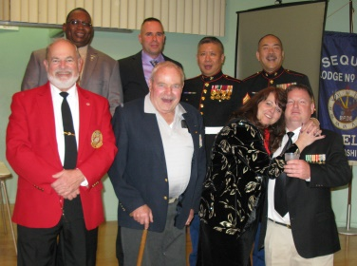
Cake, oldest/youngest Marine; Guy-Marine of Year; Brian Ledbetter, entertainer; Whidbey Marines

Detachment Christmas Party at Smuggler’s Landing Restaurant December 11th:

Twenty one Detachment members attended the Detachment Christmas party luncheon held at the Smuggler’s Landing Restaurant in Port Angeles on December 11th. Santa made an appearance and passed out candy canes. Several members won monetary raffle items including a ‘paid for dinner’ which was donated back to the Detachment.
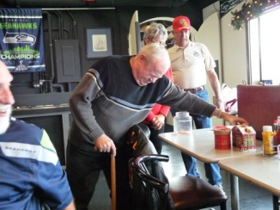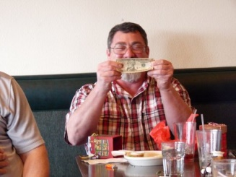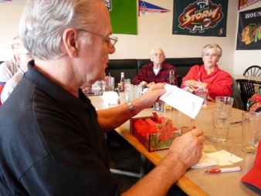
“I’ll take this one” “I won!” ‘Dinner Winner’

Community Veterans’ Dinner at Smuggler’s Landing December 18th:

Several Detachment members attended the 5th annual Community Veterans Dinner provided by Smuggler’s Landing Restaurant owner Rick Mathis. Pictured here are Mark, Diana, Guy, Sid, Jean, Don and Esther.
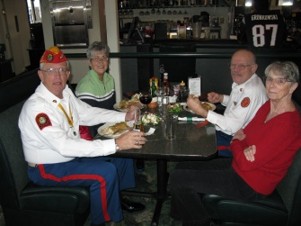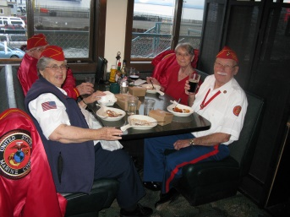

Donation to Detachment:

SSGT Donald Faria of Chimacum contacted Commandant Mark and offered several ‘Bear Marines’ to our Detachment. These ‘Bear Marines’ are collector items with individual numbers on them. Mark decided to give each member of the Honor Guard a Bear as a ‘Thank You’ for all they do for the Detachment beyond providing rifle salutes at funerals/memorials and ceremonies.
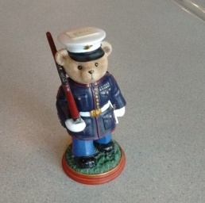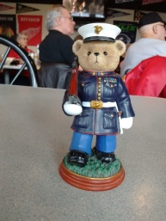

HAPPY NEW YEAR!
Semper Fi

Respectfully submitted,
Diana Schildknecht, Newsletter Editor

